**Whatsapp Documentation**

To Update the chrome driver for the whatsapp application.

The closing of window while sending messages is due to chrome driver not being updated. Therefore, to update the driver.

1. [Link](https://chromedriver.chromium.org/downloads), Go to this link and select the appropriate driver for the chrome.

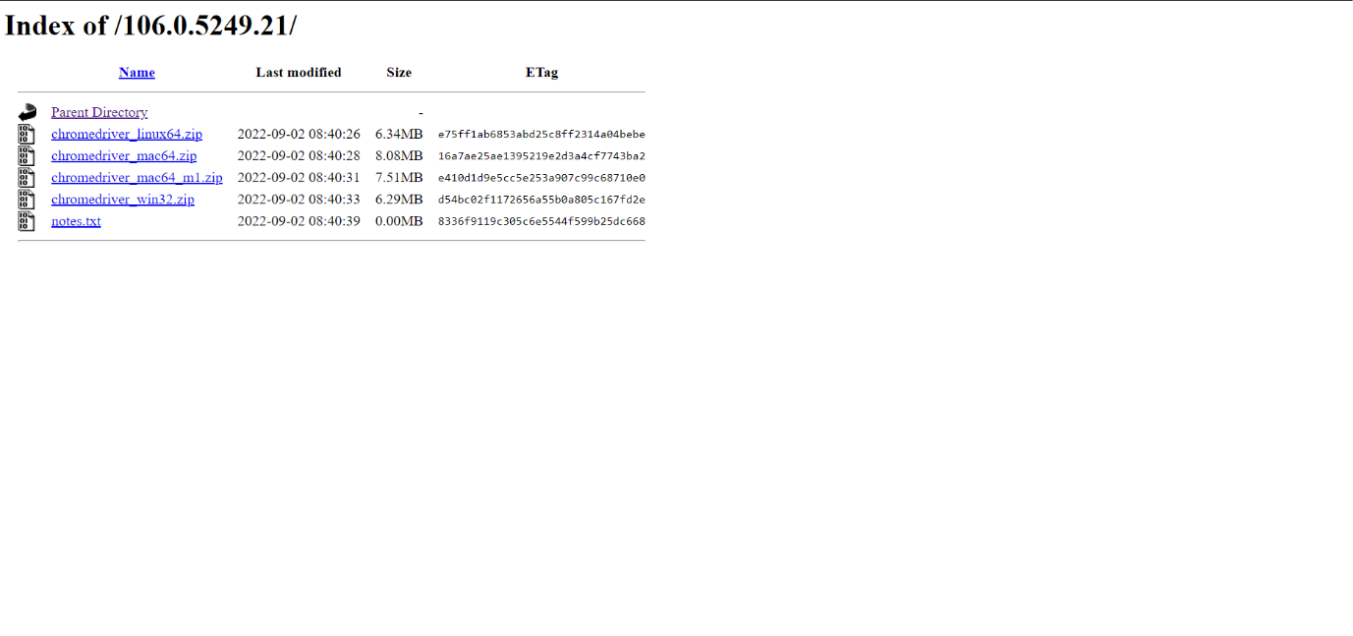

1. Then select the chromedriver_win.zip and download it.
2. Unzip it and replace it with the previous driver in dist folder.

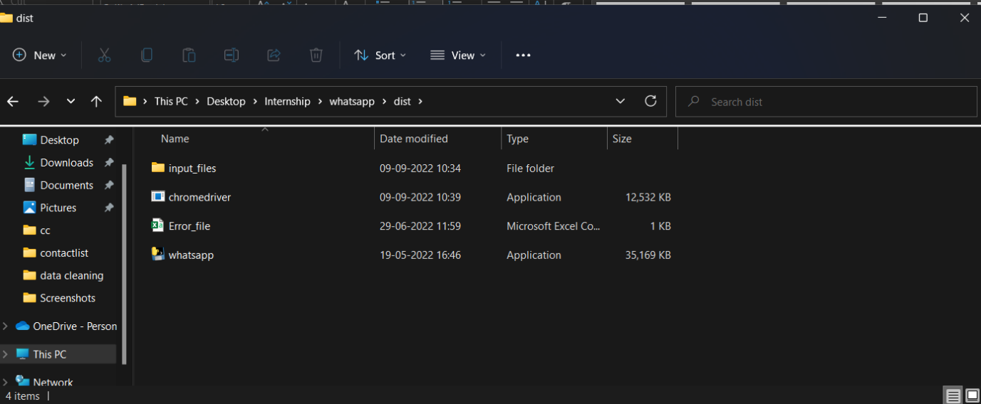

This would solve the chrome driver issue.